# Guided Capstone Project Report

Big Mountain Resort, a ski resort in Montana, recently installed a new chairlift that will increase operating expenses by $1,540,000. To potentially offset this cost, Big Mountain has requested a data-scientific analysis of ski resort data to discover whether the resort can raise ticket prices based on the facilities available to customers.

Big Mountain currently charges $81 for an adult ticket, placing it slightly above average:

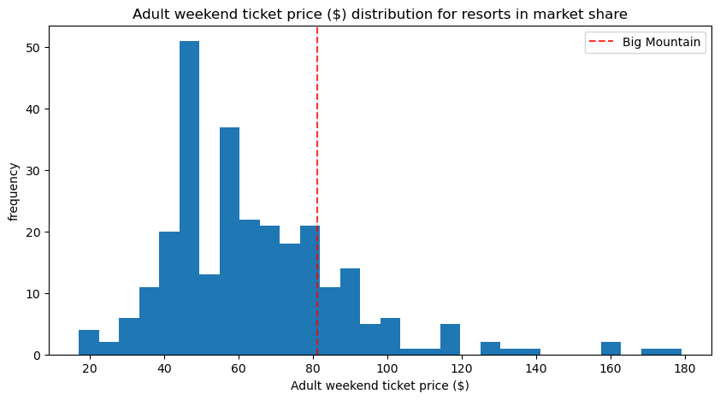

## Data modeling

The random forest model we used was optimized by placing a high emphasis on four factors: fast quads, runs, snow-making acreage, and vertical drop. Other factors are taken into account, but the model found these four to be most important when predicting lift ticket price.

The random forest model, after being retrained on all of the data available on each of the resorts, predicted that Big Mountain Resort's adult weekend ticket price at $95.87 (with an expected mean average error of $10.39).

## Predicting the value of potential cost-saving and revenue-increasing measures

Using the random forest model, we analyzed four different cost-saving and/or revenue-increasing possibilities.

Big Mountain Resort has considered the following four steps:

1. Closing down up to 10 of the least-used runs on the mountain.
2. Adding one run that increases the vertical drop of the mountain by 150 ft. alongside a new chairlift.
3. Adding one run that increases the vertical drop of the mountain by 150 ft. alongside a new chairlift as well as two additional acres of snow-making capabilities.
4. Increasing the length of the longest run on the mountain by 0.2 miles and adding 4 acres of snow-making capabilities.

After analyzing each of the four scenarios, it's clear that options 1 and 2 are the most viable for improving profitability. However, further information on operating costs is needed before we can make a stronger recommendation.

## Business recommendations

The modeled ticket price of around $96 with an expected mean error of $10 leads us to recommend a conservative price increase of $5 for a new ticket price of $86. Based on the visitor information provided by Big Mountain Resort, this is projected to provide an additional $8,750,000 of revenue, more than covering the operating costs of the new lift.

Big Mountain should also dig a bit deeper into cost-saving and revenue-generating ideas. For example, to make a recommendation on closing the least-used runs, we would need to estimate the cost savings to see if they would offset the reduced revenue predicted by the model (up to $3,000,000 less if 10 runs are closed).

Adding a new run would also incur additional operating costs – especially if a new lift is installed – and while the model predicts additional revenue of around $3,500,000 for these new features, the installation and operating costs could change the overall picture of this option.